CSC 314, Lab #13, Spring 2025 Name: ________________________
HMM and Galaxy

Part I

The HMM below models gene regions (G) and non-gene regions (N), based on the fact that genes have higher GC content (guanine and cytosine nucleotides) than non-gene regions. All probabilities are on the log2 scale.

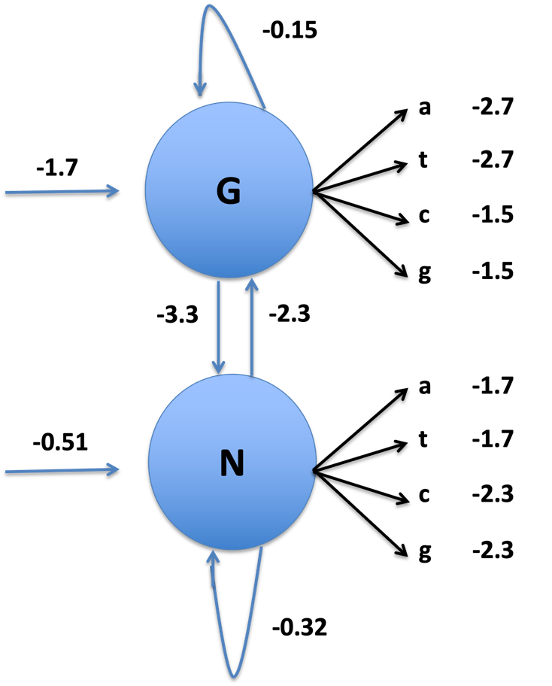

- What is the initial state probability for “G”, $P(G)$? Give the probability, and not the probability on the log2 scale (rounded to 3 decimal places)

- What is the transition probability $P(G_{i+1}|N_{i})$? Give the probability, and not the probability on the log2 scale (rounded to 3 decimal places).

Suppose the following sequence is observed: aaggc. Use the matrix below to answer the remaining questions in this section.

 | a | a | g | g | c
Gene (G) | -4.4 | -7.21 | -8.03
Non-Gene (N) | -2.21 | -4.23 | -6.85

- What is the optimal (predicted) gene structure for the dinucleotide sequence aa? The probability of that structure (given aa) is proportional to what value?

- Complete the above dynamic programming matrix (you must show your work)

- What is the optimal (predicted) gene structure for the nucleotide sequence aaggc?

- Suppose that the same HMM is used to analyze a sequence that is 1000 nucleotides long. The number of possible hidden states is an extremely large number that begins with a 1. How many digits are in this number?

- Using the Viterbi algorithm, how many probability calculations are made when finding the optimal hidden state sequence (Note: you can assume that each state requires the same number of calculations).

Part II

- Use Galaxy (https://usegalaxy.org) to find the number of genes on each chromosome, not including pseudogenes. Paste the links below for the following:

  - your history analyzing the partial gene list (human_genes_partial.tsv)

  - your workflow for counting the number of genes on each chromosome

  - your history analyzing the full gene list (human_genes.tsv)

